1，Command line content
TN_MTK_TSDC_Flashtool_V5.2404.exe -c download -s path/MT6768_Android_scatter.txt -d toolpath/DA_SWSEC_2404_lamu_dl_forbidden.bin

EX:TN_MTK_TSDC_Flashtool_V5.2404.exe -c download -s D:\TN_WORK\Package\fastboot_lamu_factory_userdebug_15_VVTA35.51-F.4_c012cf_test-keys\MT6768_Android_scatter.txt -d D:\TN_WORK\Code\MTK\Flashtool\2404\329\AfterSale\Lamu_Flash_Tool_Console_AfterSale_exe_5.2404.01.000\DA_SWSEC_2404_lamu_dl_forbidden.bin
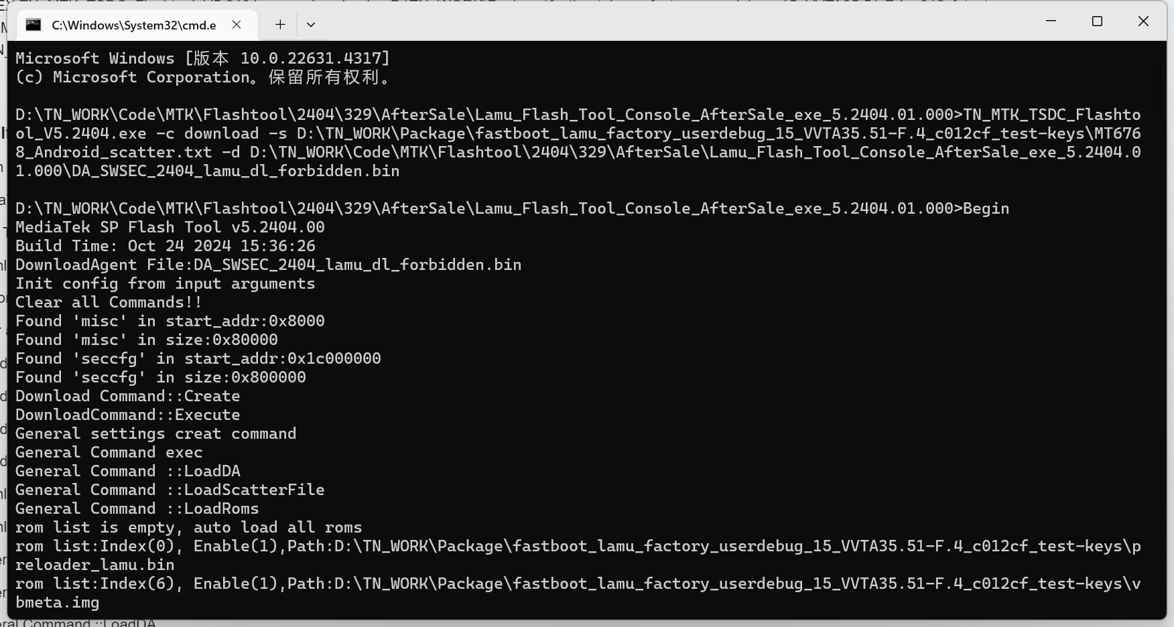
2,Self-checking log
Begin
MediaTek SP Flash Tool v5.2404.00
Build Time: Oct 24 2024 15:36:26
DownloadAgent File:DA_SWSEC_2404_lamu_dl_forbidden.bin
Init config from input arguments
Clear all Commands!!
Found 'misc' in start_addr:0x8000
Found 'misc' in size:0x80000
Found 'seccfg' in start_addr:0x1c000000
Found 'seccfg' in size:0x800000
Download Command::Create
DownloadCommand::Execute
General settings creat command
General Command exec
General Command ::LoadDA
General Command ::LoadScatterFile
General Command ::LoadRoms
rom list is empty, auto load all roms
rom list:Index(0), Enable(1),Path:D:\TN_WORK\Package\fastboot_lamu_factory_userdebug_15_VVTA35.51-F.4_c012cf_test-keys\preloader_lamu.bin
rom list:Index(6), Enable(1),Path:D:\TN_WORK\Package\fastboot_lamu_factory_userdebug_15_VVTA35.51-F.4_c012cf_test-keys\vbmeta.img
rom list:Index(7), Enable(1),Path:D:\TN_WORK\Package\fastboot_lamu_factory_userdebug_15_VVTA35.51-F.4_c012cf_test-keys\vbmeta_system.img
rom list:Index(8), Enable(1),Path:D:\TN_WORK\Package\fastboot_lamu_factory_userdebug_15_VVTA35.51-F.4_c012cf_test-keys\vbmeta_vendor.img
rom list:Index(21), Enable(1),Path:D:\TN_WORK\Package\fastboot_lamu_factory_userdebug_15_VVTA35.51-F.4_c012cf_test-keys\modem.img
rom list:Index(22), Enable(1),Path:D:\TN_WORK\Package\fastboot_lamu_factory_userdebug_15_VVTA35.51-F.4_c012cf_test-keys\spmfw.img
rom list:Index(23), Enable(1),Path:D:\TN_WORK\Package\fastboot_lamu_factory_userdebug_15_VVTA35.51-F.4_c012cf_test-keys\scp.img
rom list:Index(24), Enable(1),Path:D:\TN_WORK\Package\fastboot_lamu_factory_userdebug_15_VVTA35.51-F.4_c012cf_test-keys\sspm.img
rom list:Index(25), Enable(1),Path:D:\TN_WORK\Package\fastboot_lamu_factory_userdebug_15_VVTA35.51-F.4_c012cf_test-keys\gz.img
rom list:Index(26), Enable(1),Path:D:\TN_WORK\Package\fastboot_lamu_factory_userdebug_15_VVTA35.51-F.4_c012cf_test-keys\lk.img
rom list:Index(27), Enable(1),Path:D:\TN_WORK\Package\fastboot_lamu_factory_userdebug_15_VVTA35.51-F.4_c012cf_test-keys\boot.img
rom list:Index(28), Enable(1),Path:D:\TN_WORK\Package\fastboot_lamu_factory_userdebug_15_VVTA35.51-F.4_c012cf_test-keys\vendor_boot.img
rom list:Index(29), Enable(1),Path:D:\TN_WORK\Package\fastboot_lamu_factory_userdebug_15_VVTA35.51-F.4_c012cf_test-keys\init_boot.img
rom list:Index(30), Enable(1),Path:D:\TN_WORK\Package\fastboot_lamu_factory_userdebug_15_VVTA35.51-F.4_c012cf_test-keys\dtbo.img
rom list:Index(31), Enable(1),Path:D:\TN_WORK\Package\fastboot_lamu_factory_userdebug_15_VVTA35.51-F.4_c012cf_test-keys\logo.img
rom list:Index(32), Enable(1),Path:D:\TN_WORK\Package\fastboot_lamu_factory_userdebug_15_VVTA35.51-F.4_c012cf_test-keys\tee.img
rom list:Index(52), Enable(1),Path:D:\TN_WORK\Package\fastboot_lamu_factory_userdebug_15_VVTA35.51-F.4_c012cf_test-keys\super.img
rom list:Index(53), Enable(1),Path:D:\TN_WORK\Package\fastboot_lamu_factory_userdebug_15_VVTA35.51-F.4_c012cf_test-keys\userdata.img
General Command ::LoadAuthFile
General Command ::LoadCertFile
General command exec done!
Connection create done!
Command (0)::Execute
Connecting to BROM...
Scanning USB port...
Search usb, timeout set as 120000 ms
USB port is obtained. path name(\?\usb#vid_0e8d&pid_2000#6&15423f66&0&1#{a5dcbf10-6530-11d2-901f-00c04fb951ed}), port name(MediaTek PreLoader USB VCOM (Android) (COM36))
USB port detected: \?\usb#vid_0e8d&pid_2000#6&15423f66&0&1#{a5dcbf10-6530-11d2-901f-00c04fb951ed}
BROM connected
Downloading & Connecting to DA...
connect DA end stage: 2, enable DRAM in 1st DA: 0
Download DA now...
50% of DA has been sent.
60% of DA has been sent.
100% of DA has been sent.
DA SLA enabled status: Enabled.
DA Connected
Check Storage Life Cycle: S_DONE(0)
executing DADownloadAll...
Downloading bootloader...
100% of bootloader has been sent (316.15K of 316.15K)
Downloading bootloader...
Downloading images...
100% of image data has been sent (8.00K of 8.00K)
Downloading images...
Downloading images...
Downloading images...
20% of image data has been sent (10.00M of 49.47M)
40% of image data has been sent (20.00M of 49.47M)
60% of image data has been sent (30.00M of 49.47M)
80% of image data has been sent (40.00M of 49.47M)
100% of image data has been sent (49.47M of 49.47M)
Downloading images...
Downloading images...
Downloading images...
Downloading images...
Downloading images...
Downloading images...
21% of image data has been sent (14.00M of 64.00M)
28% of image data has been sent (18.00M of 64.00M)
56% of image data has been sent (36.00M of 64.00M)
84% of image data has been sent (54.00M of 64.00M)
Downloading images...
21% of image data has been sent (14.00M of 64.00M)
28% of image data has been sent (18.00M of 64.00M)
56% of image data has been sent (36.00M of 64.00M)
84% of image data has been sent (54.00M of 64.00M)
Downloading images...
50% of image data has been sent (4.00M of 8.00M)
100% of image data has been sent (8.00M of 8.00M)
Downloading images...
50% of image data has been sent (4.00M of 8.00M)
100% of image data has been sent (8.00M of 8.00M)
Downloading images...
Downloading images...
Downloading images...
Downloading images...
Downloading images...
Downloading images...
Downloading images...
Downloading images...
Downloading images...
Downloading images...
Downloading images...
Downloading images...
Downloading images...
Downloading images...
Downloading images...
Downloading images...
1% of image data has been sent (28.00M of 2.54G)
2% of image data has been sent (54.00M of 2.54G)
3% of image data has been sent (80.00M of 2.54G)
4% of image data has been sent (106.00M of 2.54G)
5% of image data has been sent (132.00M of 2.54G)
6% of image data has been sent (158.00M of 2.54G)
7% of image data has been sent (184.00M of 2.54G)
8% of image data has been sent (210.00M of 2.54G)
9% of image data has been sent (236.00M of 2.54G)
10% of image data has been sent (262.00M of 2.54G)
11% of image data has been sent (288.00M of 2.54G)
12% of image data has been sent (314.00M of 2.54G)
13% of image data has been sent (340.00M of 2.54G)
14% of image data has been sent (366.00M of 2.54G)
15% of image data has been sent (392.00M of 2.54G)
16% of image data has been sent (418.00M of 2.54G)
17% of image data has been sent (444.00M of 2.54G)
18% of image data has been sent (470.00M of 2.54G)
19% of image data has been sent (496.00M of 2.54G)
20% of image data has been sent (522.00M of 2.54G)
21% of image data has been sent (548.00M of 2.54G)
22% of image data has been sent (574.00M of 2.54G)
23% of image data has been sent (600.00M of 2.54G)
24% of image data has been sent (626.00M of 2.54G)
25% of image data has been sent (654.00M of 2.54G)
26% of image data has been sent (680.00M of 2.54G)
27% of image data has been sent (706.00M of 2.54G)
28% of image data has been sent (732.00M of 2.54G)
29% of image data has been sent (758.00M of 2.54G)
30% of image data has been sent (784.00M of 2.54G)
31% of image data has been sent (810.00M of 2.54G)
32% of image data has been sent (836.00M of 2.54G)
33% of image data has been sent (862.00M of 2.54G)
34% of image data has been sent (888.00M of 2.54G)
35% of image data has been sent (914.00M of 2.54G)
36% of image data has been sent (940.00M of 2.54G)
37% of image data has been sent (966.00M of 2.54G)
38% of image data has been sent (992.00M of 2.54G)
39% of image data has been sent (0.99G of 2.54G)
40% of image data has been sent (1.01G of 2.54G)
41% of image data has been sent (1.04G of 2.54G)
42% of image data has been sent (1.07G of 2.54G)
43% of image data has been sent (1.09G of 2.54G)
44% of image data has been sent (1.12G of 2.54G)
45% of image data has been sent (1.14G of 2.54G)
46% of image data has been sent (1.17G of 2.54G)
47% of image data has been sent (1.19G of 2.54G)
48% of image data has been sent (1.22G of 2.54G)
49% of image data has been sent (1.25G of 2.54G)
50% of image data has been sent (1.27G of 2.54G)
51% of image data has been sent (1.30G of 2.54G)
52% of image data has been sent (1.32G of 2.54G)
53% of image data has been sent (1.35G of 2.54G)
54% of image data has been sent (1.37G of 2.54G)
55% of image data has been sent (1.40G of 2.54G)
56% of image data has been sent (1.42G of 2.54G)
57% of image data has been sent (1.45G of 2.54G)
58% of image data has been sent (1.47G of 2.54G)
59% of image data has been sent (1.50G of 2.54G)
60% of image data has been sent (1.52G of 2.54G)
61% of image data has been sent (1.55G of 2.54G)
62% of image data has been sent (1.58G of 2.54G)
63% of image data has been sent (1.60G of 2.54G)
64% of image data has been sent (1.63G of 2.54G)
65% of image data has been sent (1.65G of 2.54G)
66% of image data has been sent (1.68G of 2.54G)
67% of image data has been sent (1.70G of 2.54G)
68% of image data has been sent (1.73G of 2.54G)
69% of image data has been sent (1.75G of 2.54G)
70% of image data has been sent (1.78G of 2.54G)
71% of image data has been sent (1.80G of 2.54G)
72% of image data has been sent (1.83G of 2.54G)
73% of image data has been sent (1.86G of 2.54G)
74% of image data has been sent (1.88G of 2.54G)
75% of image data has been sent (1.91G of 2.54G)
76% of image data has been sent (1.93G of 2.54G)
77% of image data has been sent (1.96G of 2.54G)
78% of image data has been sent (1.98G of 2.54G)
79% of image data has been sent (2.01G of 2.54G)
80% of image data has been sent (2.03G of 2.54G)
81% of image data has been sent (2.06G of 2.54G)
82% of image data has been sent (2.08G of 2.54G)
83% of image data has been sent (2.11G of 2.54G)
84% of image data has been sent (2.14G of 2.54G)
85% of image data has been sent (2.16G of 2.54G)
86% of image data has been sent (2.19G of 2.54G)
87% of image data has been sent (2.21G of 2.54G)
88% of image data has been sent (2.24G of 2.54G)
89% of image data has been sent (2.26G of 2.54G)
90% of image data has been sent (2.29G of 2.54G)
91% of image data has been sent (2.31G of 2.54G)
92% of image data has been sent (2.34G of 2.54G)
93% of image data has been sent (2.36G of 2.54G)
94% of image data has been sent (2.39G of 2.54G)
95% of image data has been sent (2.41G of 2.54G)
96% of image data has been sent (2.44G of 2.54G)
97% of image data has been sent (2.47G of 2.54G)
98% of image data has been sent (2.49G of 2.54G)
99% of image data has been sent (2.52G of 2.54G)
100% of image data has been sent (2.54G of 2.54G)
Downloading images...
15% of image data has been sent (14.00M of 87.76M)
20% of image data has been sent (18.00M of 87.76M)
25% of image data has been sent (22.00M of 87.76M)
45% of image data has been sent (40.00M of 87.76M)
50% of image data has been sent (44.00M of 87.76M)
70% of image data has been sent (62.00M of 87.76M)
75% of image data has been sent (66.00M of 87.76M)
95% of image data has been sent (84.00M of 87.76M)
100% of image data has been sent (87.76M of 87.76M)
download speed: 26.75MB/s.
Download Succeeded.
100% of flash has been formatted.
Format Succeeded.
0% of flash has been formatted.
100% of flash has been formatted.
Format Succeeded.
Command (1)::Execute
FlashTool_EnableWatchDogTimeout Succeeded.
All command exec done!
Disconnect!

